COMMUNICATIONS KIT

In this kit you will find the key information and tools to help spread the word about the Emergency Medicine Foundation’s (EMF) changes to its Queensland Research Program. The ‘new look’ Program includes more funding for EMF’s most popular grants as well as the introduction of new grants which are open to all Queensland Health clinicians providing direct clinical care to patients in an emergency.

Social media
Help EMF let emergency clinicians know about the new research grants available to them as well as the changes to the existing grant schemes.
- To share EMF’s posts, click here for the EMF social channels or
- Post on your social media sites and tag us (#EMFgrant/ @emfresearch)
Sample posts

Twitter | New #research grants available for #Queensland #emergency clinicians, including #nurses, #paramedics, #alliedhealth & #doctors. Grant round opens 25 June. http://emergencyfoundation.org.au/queensland-research-program/
Facebook | New research grants are on offer at EMF! The Foundation is introducing a new look research program, with new grants open to all Queensland Health clinicians providing patient care in an emergency setting. The next grant round opens 25 June. http://emergencyfoundation.org.au/queensland-research-program/
LinkedIn | EMF is introducing a new look research program for Queensland. Changes include two new grants, JumpStart and Leading Edge, which are open to all Queensland Health clinicians providing patient care in an emergency setting. The next grant round opens 25 June. http://emergencyfoundation.org.au/queensland-research-program/
Newsletter | Changes to EMF’s Queensland Research Program  The Emergency Medicine Foundation (EMF) is changing its Queensland Research Program, including increasing funding available for its most popular grants as well as introducing two new grants open to all Queensland Health clinicians providing direct clinical care to patients in an emergency.  Grants open: 10:00am AEST, 25 June 2018  More information: http://emergencyfoundation.org.au/queensland-research-program/

Image for social media (on next page)
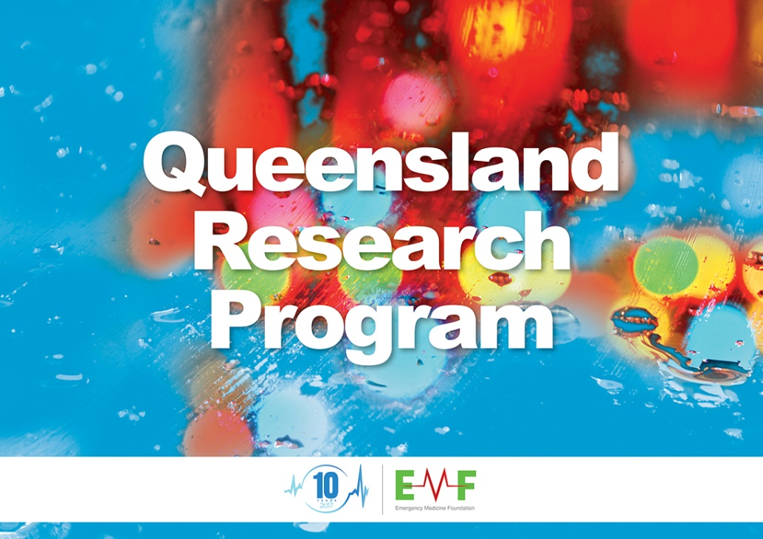

For more information:

Julia Renaud
Communications Manager
Emergency Medicine Foundation

2/15 Lang Parade  Milton Queensland  Australia 4064 |  |  | T  F  M | +61 7 3720 5700  +61 7 3876 8594  +61 458 985 358 |  |  | E  W | julia.renaud@emfoundation.org.au  www.emergencyfoundation.org.au

