COMMUNICATIONS KIT

In this kit you will find the key information and tools to help spread the word about the Emergency Medicine Foundation’s (EMF) 2018 Rural and Remote Research Program grant round.

Social media
Your help in promoting the Rural and Remote grant round is invaluable to a small organisation like EMF.
- To share EMF’s posts, click here for the EMF social channels or
- Post on your social media sites and tag us (#EMFgrant @emfresearch)
Sample posts

Twitter | Can you improve #patient outcomes or #healthcare for rural and remote Australians in an emergency? @emfresearch is calling for #EOIs now for a $50,000 #researchgrant #rural&remote #seedfunding #emergencymedicine http://emergencyfoundation.org.au/rural-and-remote-research-program/
Facebook | We like the idea of helping save the lives of Australians sick or injured in the outback. Apply now for an Emergency Medicine Foundation [@emfresearch] Rural and Remote grant if you have an innovative research idea. #researchgrant #rural&remote #seedfunding #emergencymedicine http://emergencyfoundation.org.au/rural-and-remote-research-program/]
LinkedIn | Apply now for an Emergency Medicine Foundation Rural and Remote research grant. EOIs due by 25 May 2018. #researchgrant #rural&remote #seedfunding #emergencymedicine http://emergencyfoundation.org.au/rural-and-remote-research-program/
Newsletter | Rural and Remote Research Grant EOI  The Emergency Medicine Foundation (EMF) is offering up to $50,000 to support a collaborative research project in the field of emergency medicine for the benefit of rural and remote patients within Australia.  EOI deadline: 5:00pm AEST, 25 May 2018  More information: http://emergencyfoundation.org.au/rural-and-remote-research-program/

Image for use (R&R banner also available)
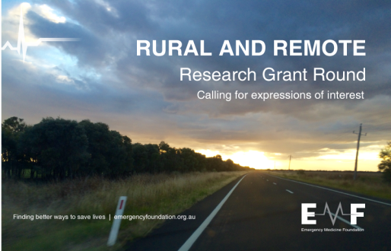
About the grant round

EMF is running a Rural and Remote Research Program grant round, offering up to $50,000 to support a collaborative research project in the field of emergency medicine for the benefit of rural and remote patients within Australia. Further funding for additional grants may be available.

Why applicants should apply

- This research grant is open to all Australian emergency healthcare clinicians, who provide direct clinical care. It offers you an opportunity to improve outcomes and/or healthcare services for patients in an emergency in rural and regional Australia.

- You will have funding to develop a research idea or further your research to a stage where you can apply for larger grants, such as through the NHMRC.

- You don’t have to be an emergency specialist to apply for this grant, with EMF encouraging applications from all emergency healthcare professionals, including (but not limited to): doctors, nurses, paramedics and allied health professionals who work in the emergency setting either in the pre-hospital or emergency department.

Benefits for Australians

- EMF is funding innovative research to improve the medical emergency survival rates for Australian’s living in rural and remote areas.

- One third of Australians live in regional, rural and remote areas. EMF believes clinician-researchers can deliver solutions to the unique challenges Australians face in accessing lifesaving healthcare during a medical emergency in the bush.

Application deadline: Expressions of Interest (EOIs) must be submitted by 5:00pm (AEST), Friday 25 May 2018.
Who is EMF?

The Emergency Medicine Foundation is an Australian not-for-profit organisation, dedicated to emergency and acute care research. Our programs fund innovative, evidence-based research with the potential to improve clinical practice in the short-term as well as deliver economic benefits to the healthcare system.

For more information:

Julia Renaud
Communications Manager
Emergency Medicine Foundation

2/15 Lang Parade  Milton Queensland  Australia 4064 |  |  | T  F  M | +61 7 3720 5700  +61 7 3876 8594  +61 458 985 358 |  |  | E  W | julia.renaud@emfoundation.org.au  www.emergencyfoundation.org.au

